Date:04.04.2022

**Third Year B. Tech., Sem VI 2021-22**

**4CS372 : Advanced Database System Lab**

**Assignment Submission**

**PRN No: 2019BTECS00064**

**Full name: Kunal Santosh Kadam**

**Batch: T2**

**Assignment: 9**

**Title of assignment: Neo4j Graph Database**

**Objective:**

Consider the “Research Papers Database”, load and query this data using Neo4j Data Browser

**Introduction & Theory:**

Neo4j is a graph database management system. Neo4j is a native graph database, built from the ground up to leverage not only data but also data relationships. Neo4j connects data as it’s stored, enabling queries never before imagined, at speeds never thought possible.

**Procedure / Experiment :**

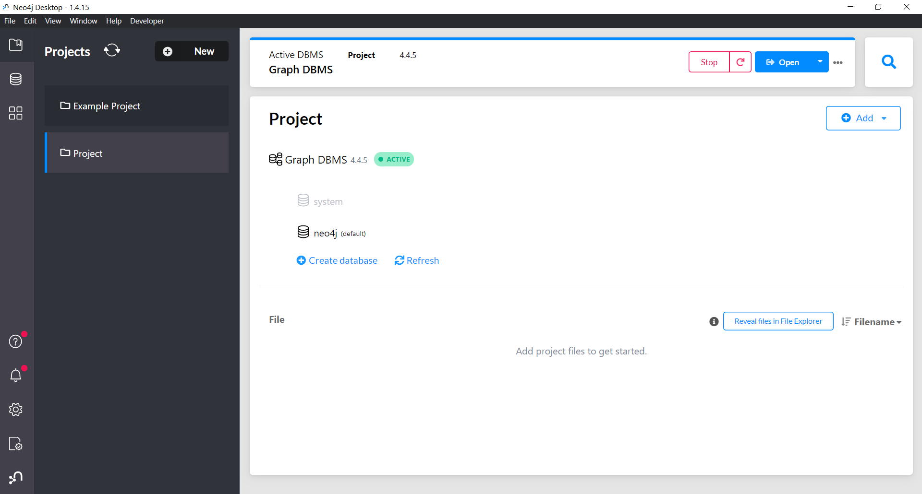

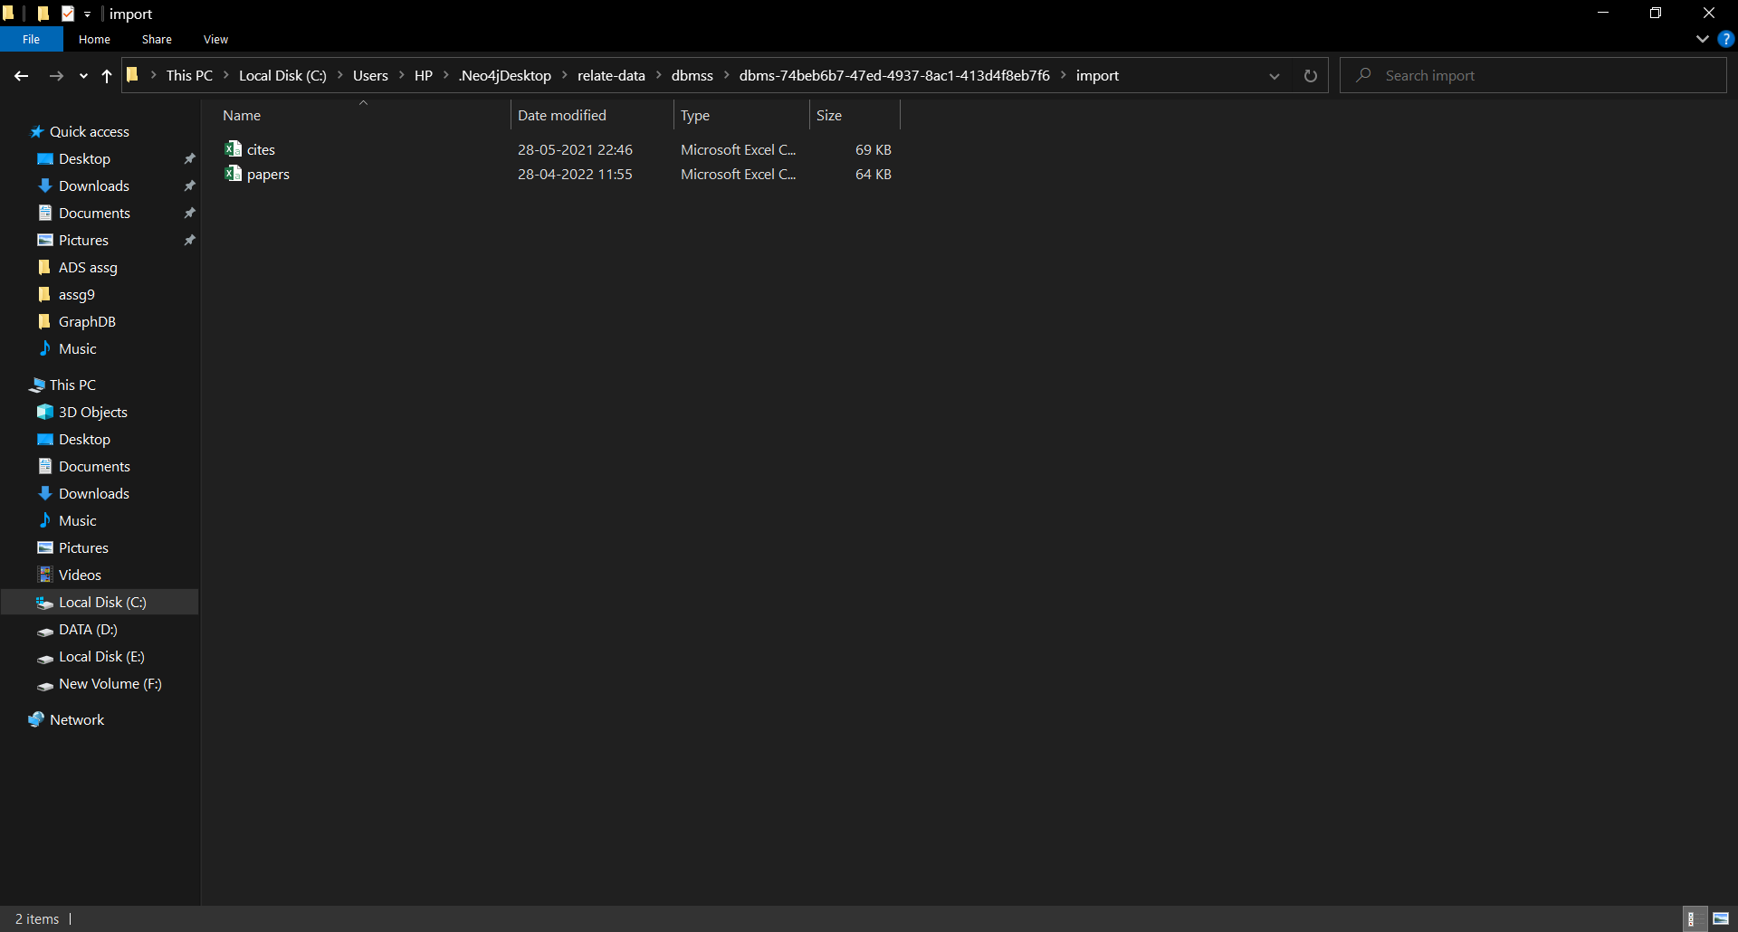

LOAD CSV WITH HEADERS FROM 'file:///papers.csv' AS line FIELDTERMINATOR ',’ CREATE (:Paper {id: line.paper_id, class: line.label})

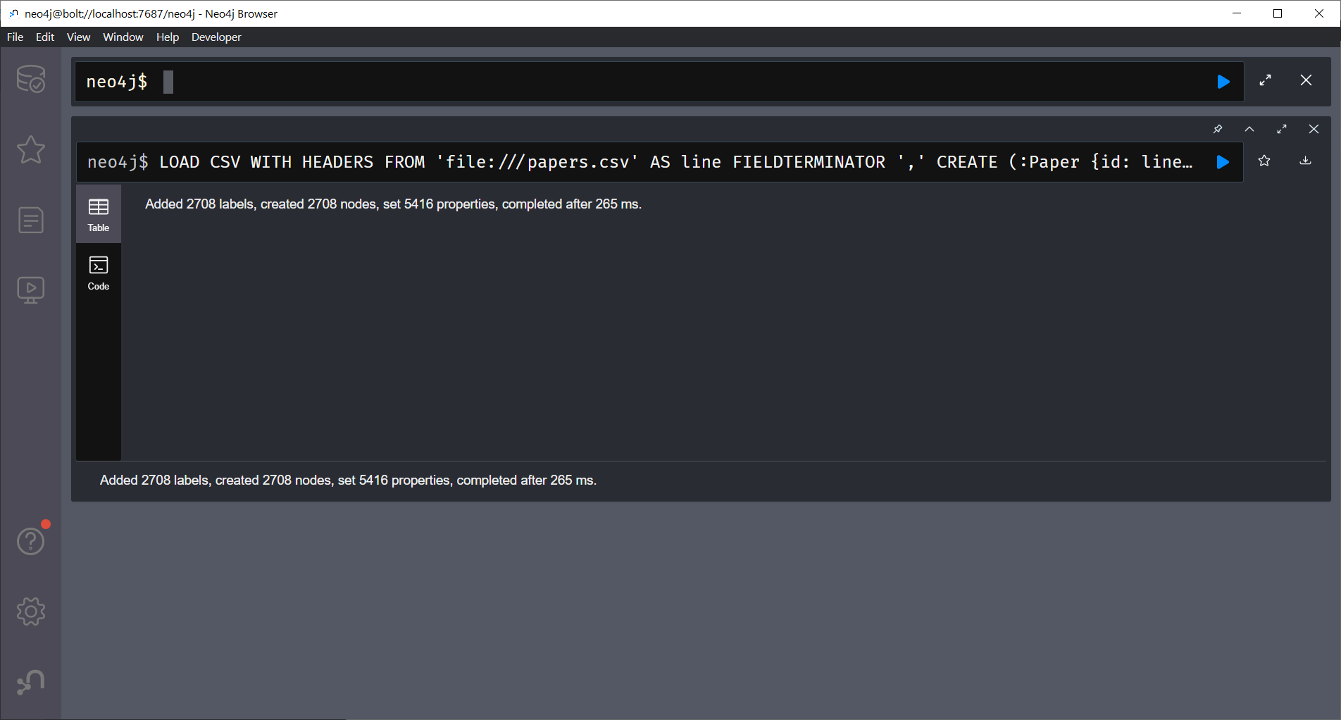

LOAD CSV WITH HEADERS FROM 'file:///cites.csv' AS line FIELDTERMINATOR ',' MATCH (citing_paper:Paper {id: line.citing_paper_id}), (cited_paper:Paper {id: line.cited_paper_id}) CREATE (citing_paper)-[:CITES]->(cited_paper)

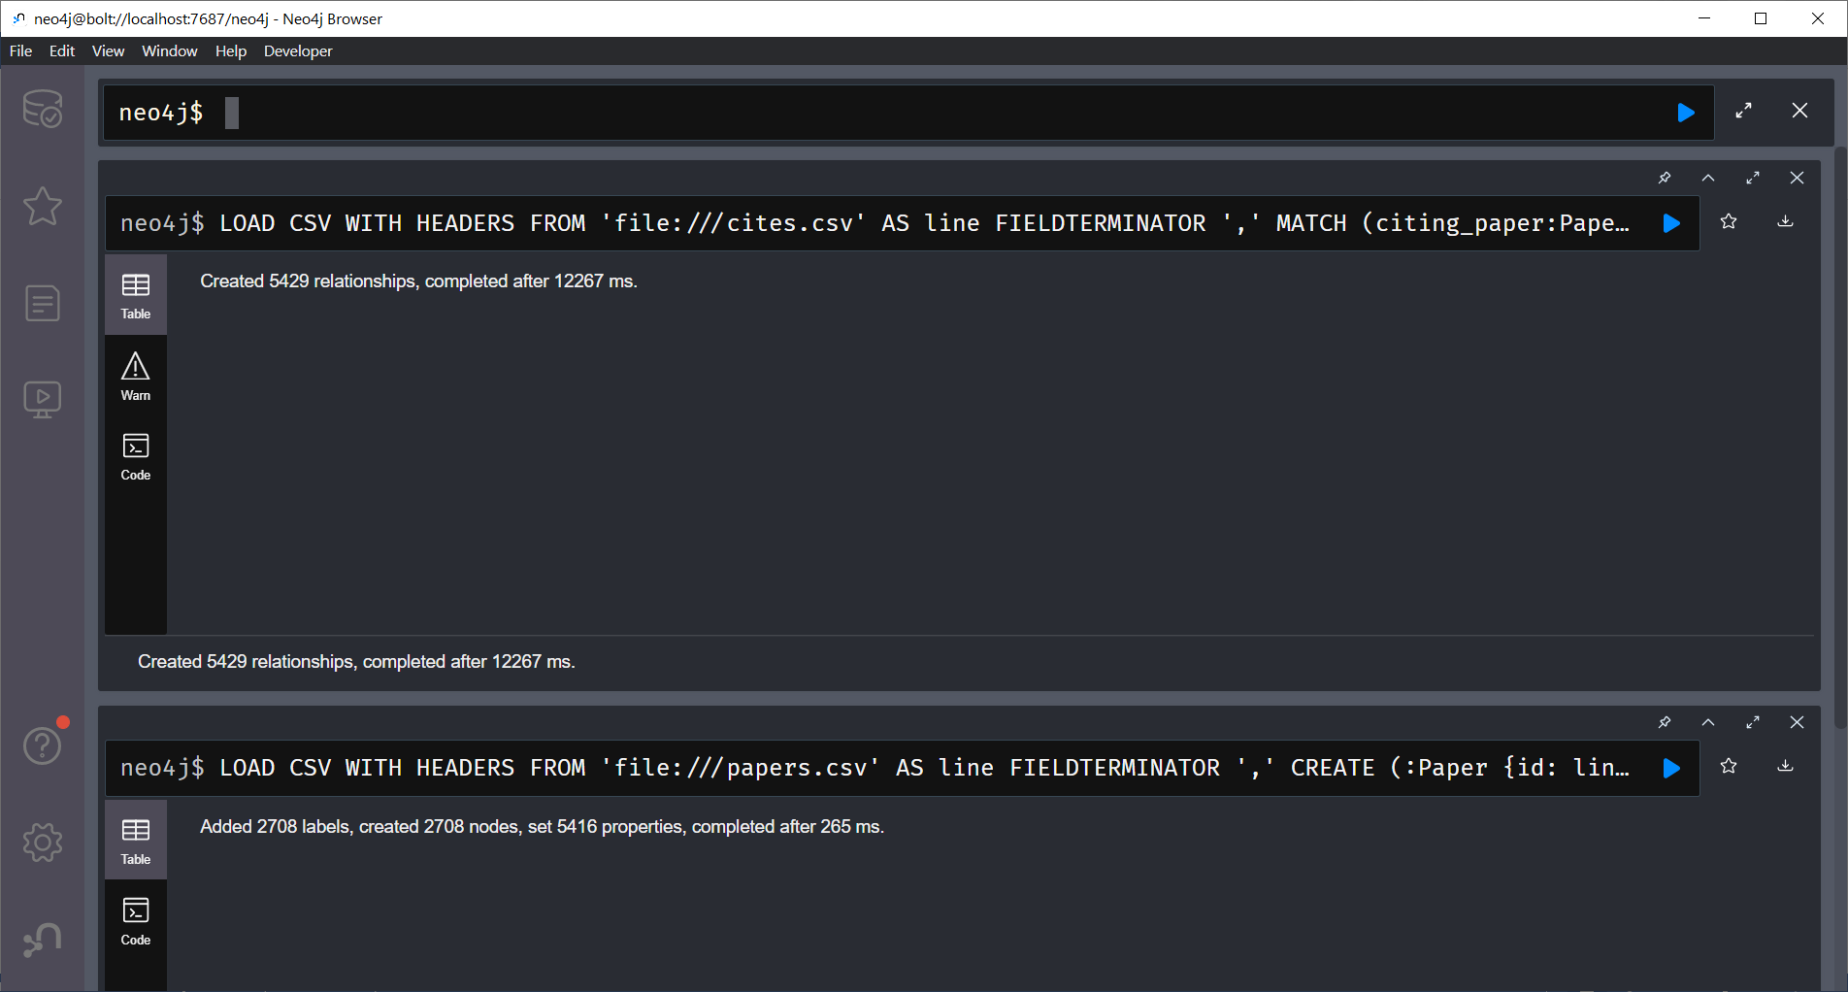

MATCH (p:Paper) RETURN DISTINCT p.class ORDER BY p.class

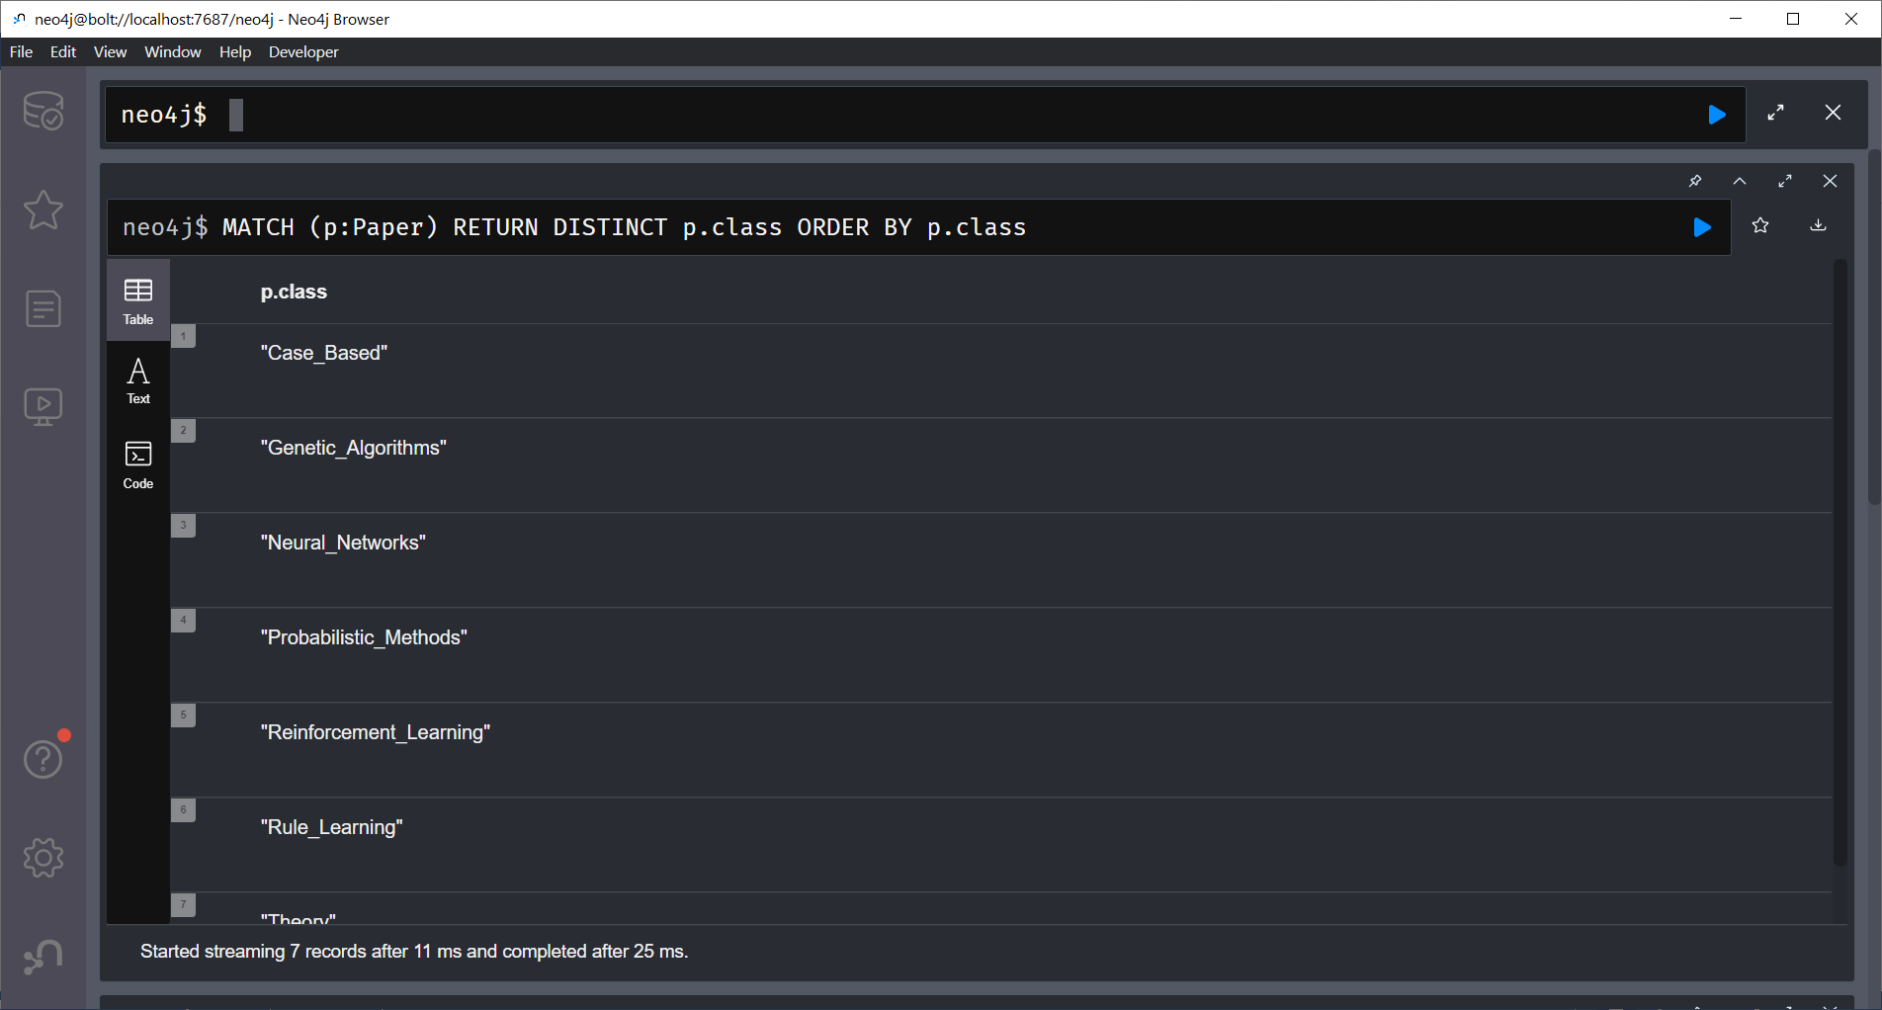

MATCH p=()-[r:CITES]->() RETURN p

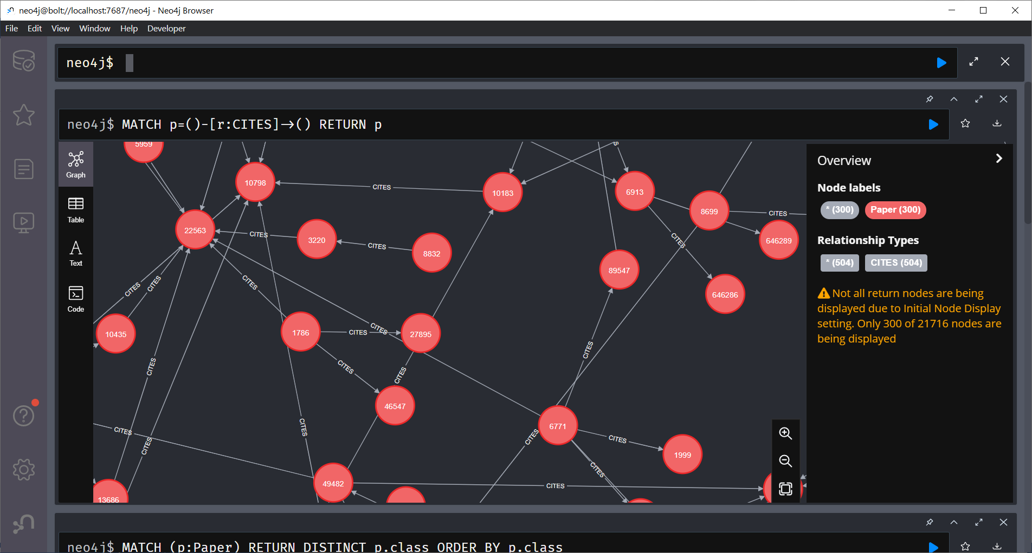

MATCH (n:Paper) RETURN n

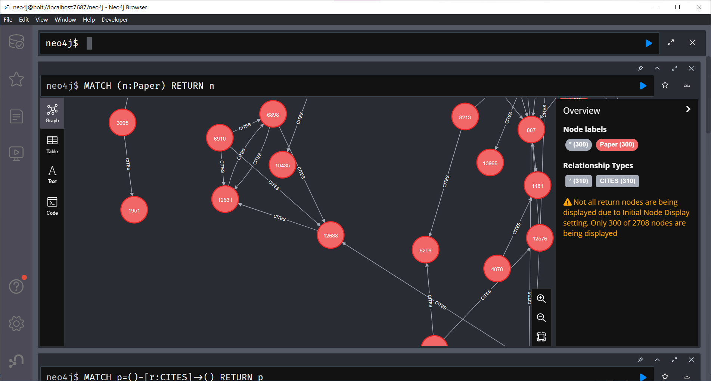

**Application**

application.py

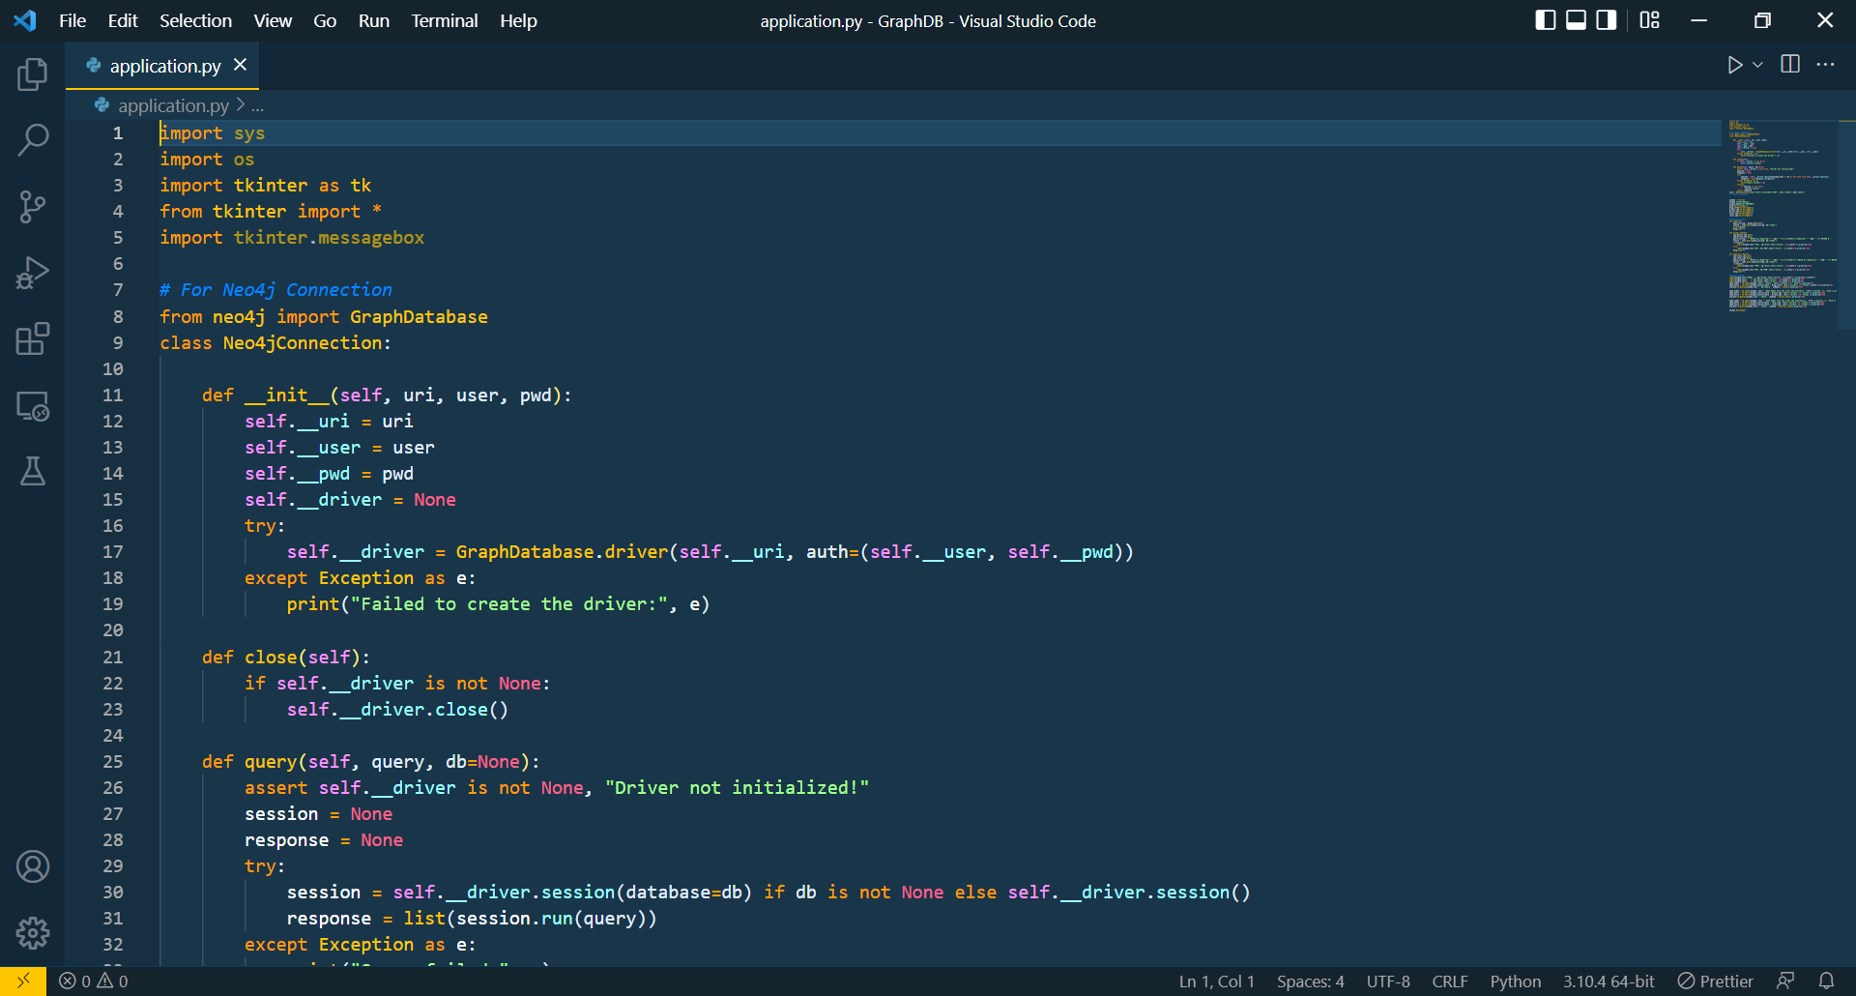

**GUI**

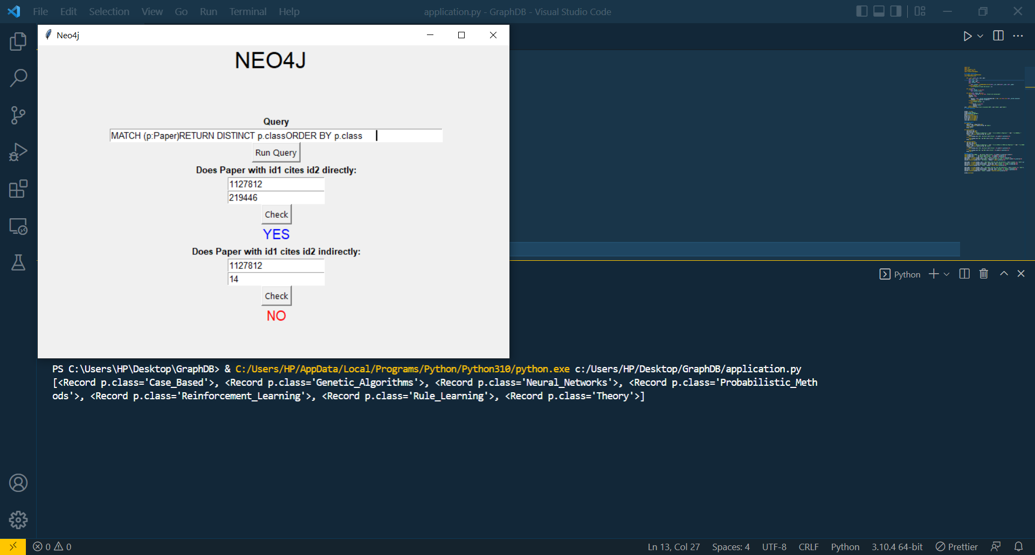

**Conclusion:**

Able to load data from “Research Papers Database” and to perform queries on this data. Able to create python application connected with neo4j database.

**References:**

https://neo4j.com/